**Subscriber ID =** cartyogi.com/ondcbuyer

**Subscriber_url:**[**https://buyerapi.cartyogiondc.com**](https://buyerapi.cartyogiondc.com/)

Search

Search Request

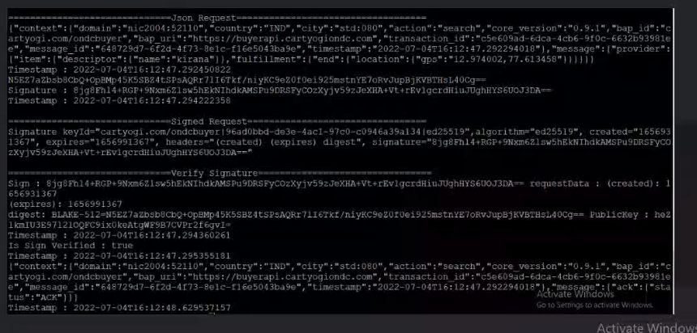

Search (on_Search) Response

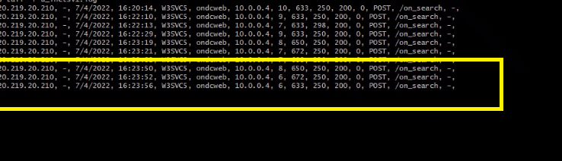



Select Request

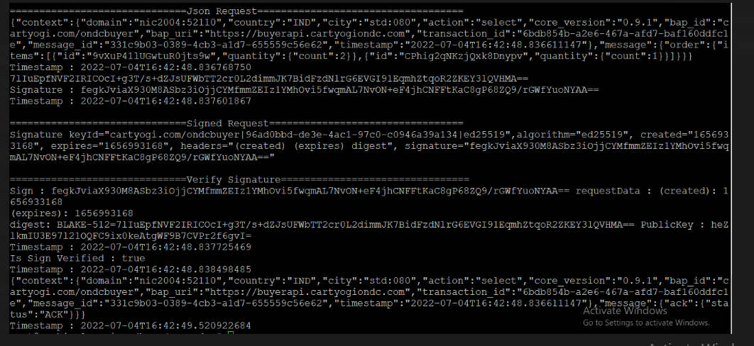

Select (on_select) Response





Init Request

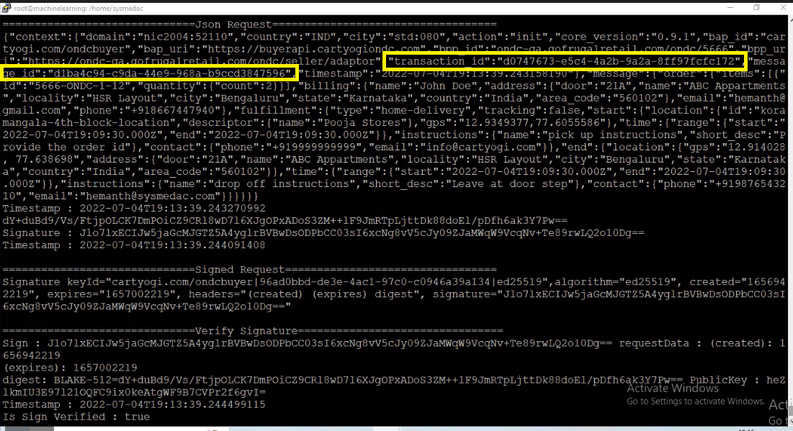

Init (on_init) Response

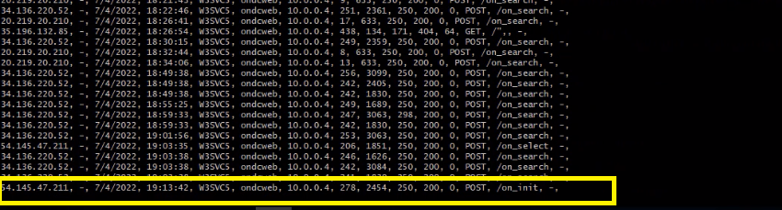



Confirm Request

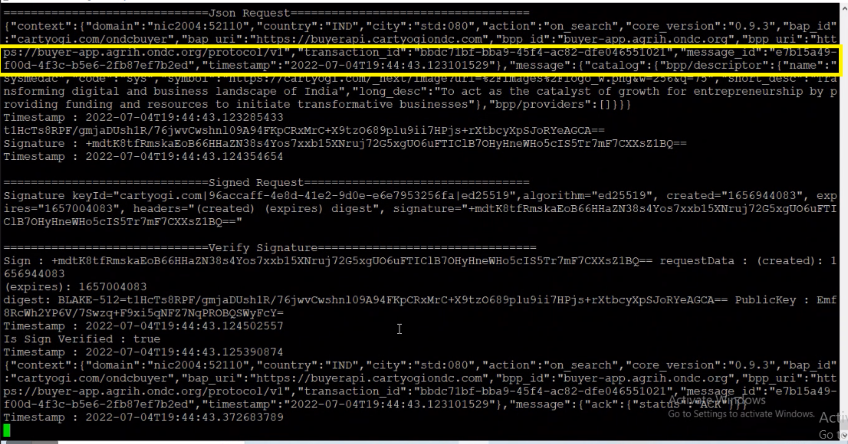

Confirm (on_confirm) Response



